**MGB Center for COVID Innovation**

**Face Shields Working Group**

**Lewis Lab All Plastic Face Shield**

**Manufacturing Specifications**

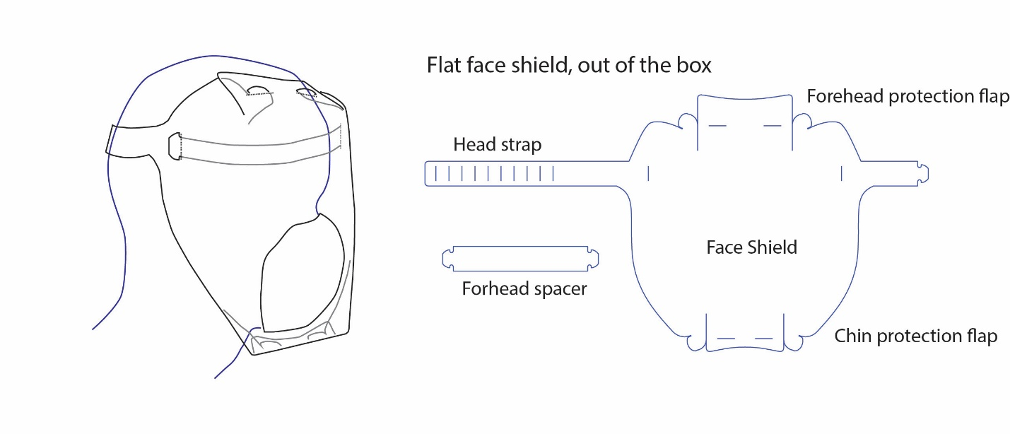

1. **Bill of materials – per unit** 
   1. Anti-fog coated PET transparent film
      1. Minimum roll width of 20”
      2. Thickness: 0.010” - 0.015”
2. **Manufacturing process details** 
   1. Die cutting of PET film
      1. Material: PET film (transparent)
      2. Coating: Anti-fog coating
      3. Dimensions refenced on the drawings
   2. Flat packaging for shipment
3. **Product specification sheet**

* Low-cost, disposable
* Anti-fog treated
* Chin protection
* Can be cleaned by with alcohol-based antiseptic wipes for extended use or re-use
* Comfortable for a full day shift (up to 12 hours)
* Can be used with general PPE (surgical mask, N95 respirator, hair net)
* Can be used with stethoscope and other general clinical tools

1. **Drawings** 
   1. PET transparent film:

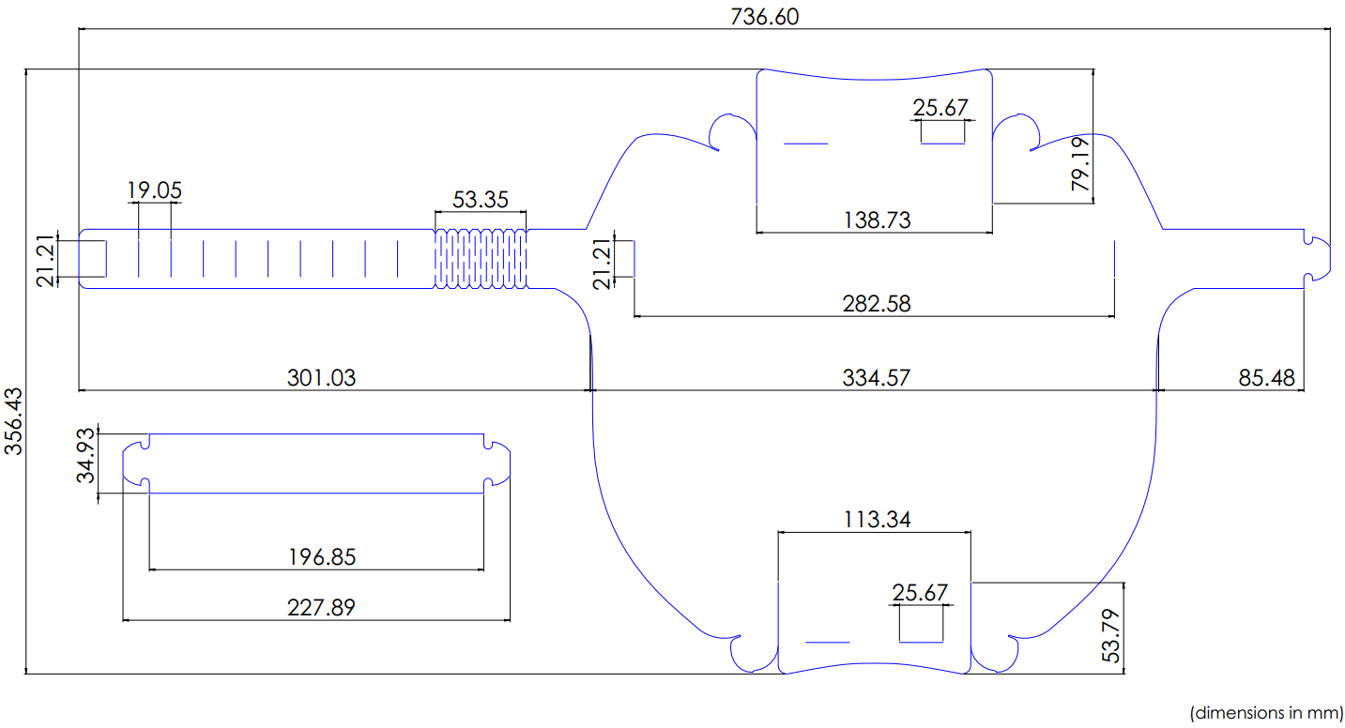

1. **General use of device**

This shield is intended to be used as a general-purpose disposable face shield, and a general replacement for the Face Shields used at the hospitals.

This shield is NOT intended for: surgical use, uses where significant amounts of exposure to hazardous fluid is expected, situations where level 3 or 4 protection is required, situations where exposure to high heat or flammable gas can occur.

1. **Instructions for use (a graphical version will be provided to the user)**
2. Fold the chin protection flap and latch in place.
3. Fold the head protection flap and latch in place.
4. Insert forehead spacer to its slots.
5. Adjust headstrap for your size by slotting the headstrap through appropriate tabs.
6. Don/doff using standard methods.